Sound Production Workshops

Our resident sound guy Mike Chapman is taking enrollments for his Sound Production workshop starting soon.

*What is it?* Home studio recording. Learn how to record your own music on your own computer. What software do you need? What hardware is necessary? Mike has the answers! During the workshop, you'll record a track with him to learn the skills necessary to do it at home.

**About**

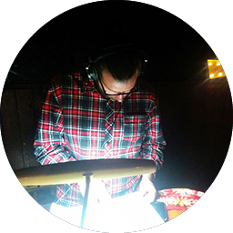Mike has a Bachelor of Music Composition and Production from Australian Institute of Music (AIM) Sydney.

He is the sound engineer of the [Rubber Soul Lounge](http://www.rubbersoullounge.com/), responsible for mixing and recording artists. Also a teacher at Penny Lanes Music School, he workshops on **music composition** and **home studio recording**.

Proficient in the use of Digital Audio Workstations such as **Logic, Pro Tools, Reason, and Ableton.** If you would like to learn how to make your own quality demos at home or even if you want to learn basic production techniques and ways to improve your songwriting, get in touch.

**Sample**

**Enroll**

Email: [pennylanesmusic@hotmail.com](mailto:pennylanesmusic@hotmail.com,mykchap@hotmail.com?subject=re:%20Sound%20Production%20Inquiry)

Check out his [profile page here](http://www.rubbersoullounge.com/mikechapman/) for samples of his work and contact information.